Instructions to sign up for subscription parking.
- Go to Premium Parking
- Enter 8602 for Maddison Lot.
- Enter 8603 for Woodburn lot.
- Click signup for subscription.
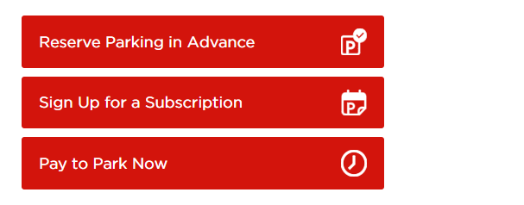

- Click view rate.
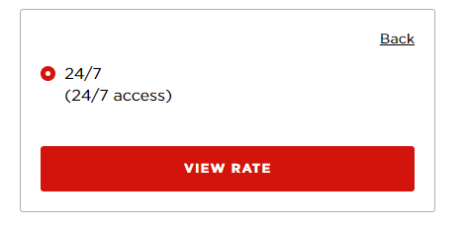
- Select Start date then park here.
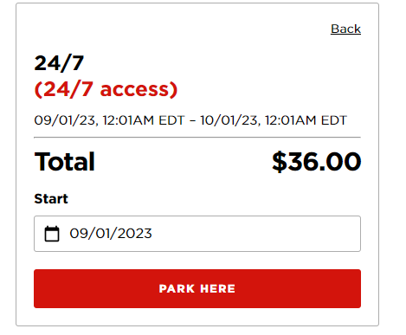
- Enter personal information and payment information.
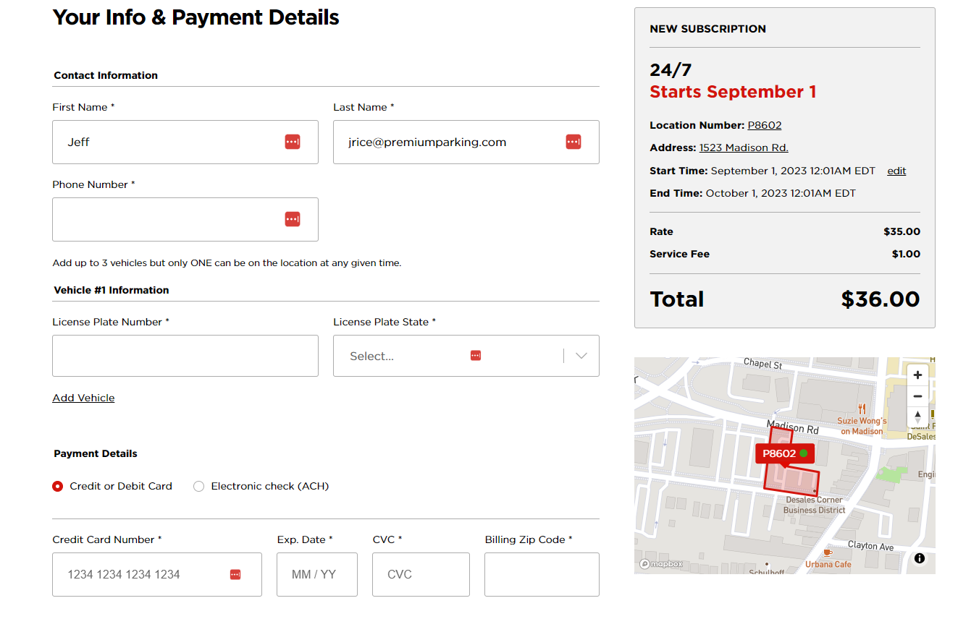
- Click pay.
